**COOKIES**

**CREATE A PROJECT**

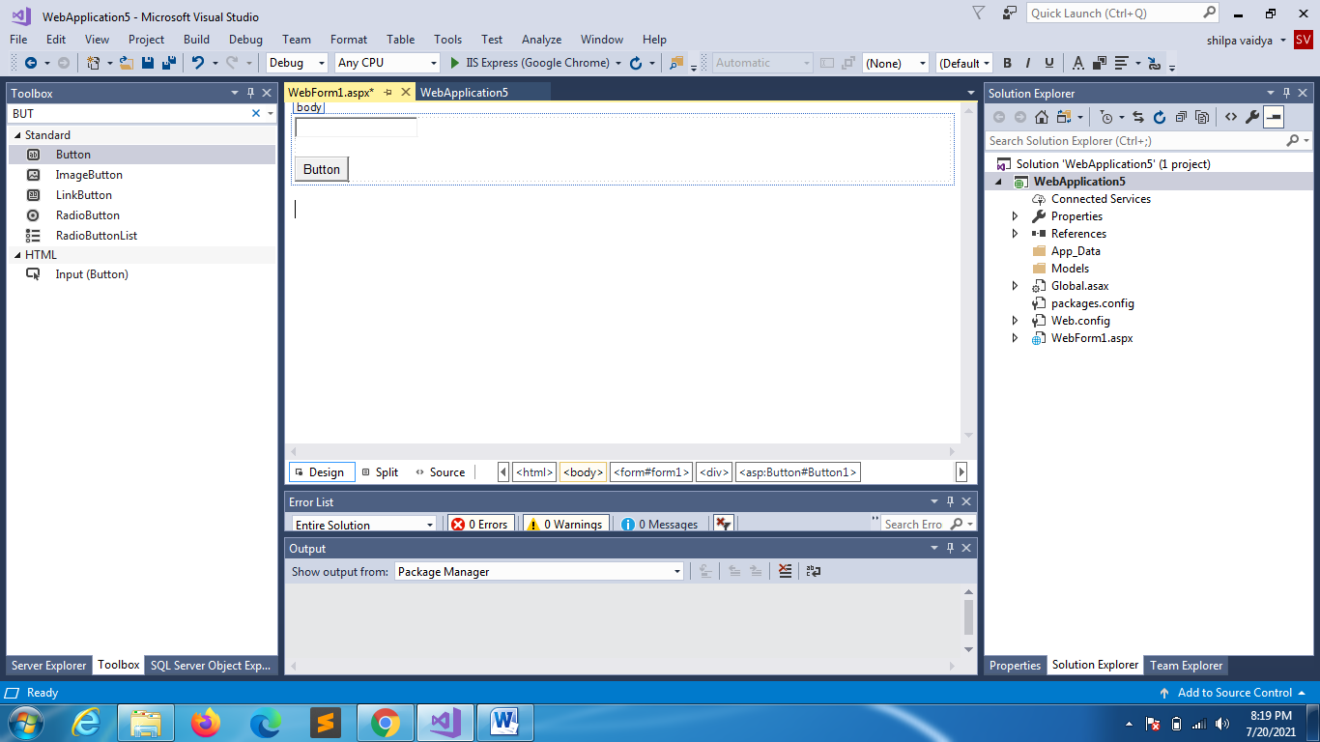

using System;

using System.Collections.Generic;

using System.Linq;

using System.Web;

using System.Web.UI;

using System.Web.UI.WebControls;

namespace WebApplication5

{

public partial class WebForm1 : System.Web.UI.Page

{

protected void Page_Load(object sender, EventArgs e)

{

}

protected void Button1_Click(object sender, EventArgs e)

{

HttpCookie cookie = new HttpCookie("MyCookie");

cookie.Value = TextBox1.Text;

cookie.Expires = DateTime.Now.AddSeconds(30);

Response.Cookies.Add(cookie);

Response.Redirect("WebForm2.aspx");

}

}

}

WebForm2

using System;

namespace WebApplication5

{

public partial class WebForm2 : System.Web.UI.Page

{

protected void Page_Load(object sender, EventArgs e)

{

string str1 = Request.Cookies["MyCookie"].Value;

Response.Write(str1);

}

}

}

Later for the WebForm2.aspx add button

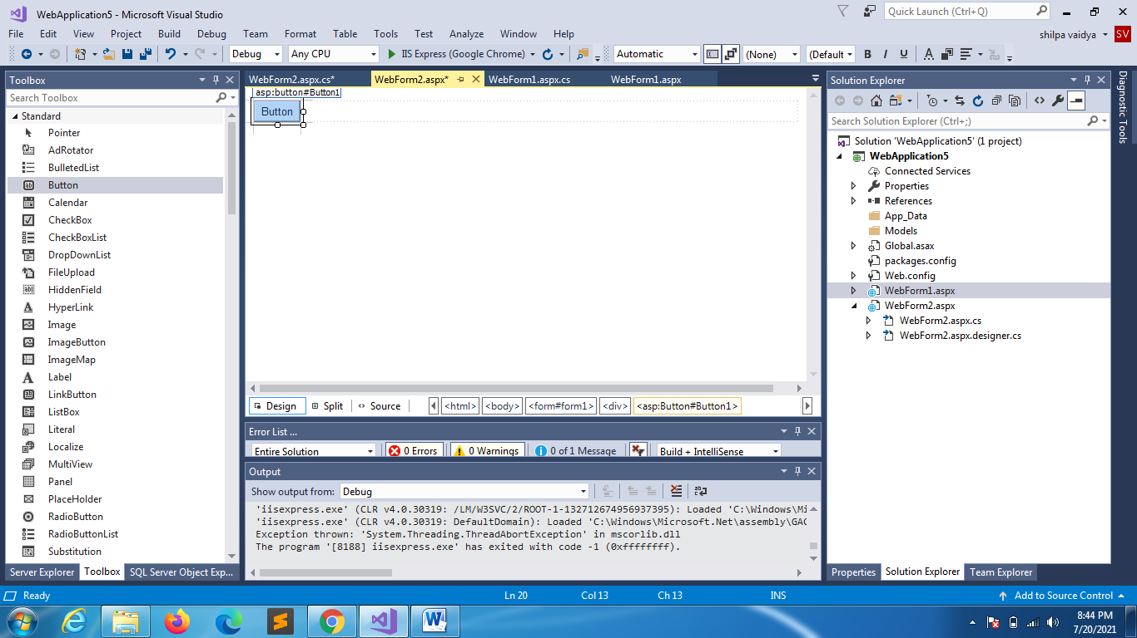

using System;

namespace WebApplication5

{

public partial class WebForm2 : System.Web.UI.Page

{

protected void Page_Load(object sender, EventArgs e)

{

if(!IsPostBack)

This will throw error because the cookie is stored only for 30 seconds

{

string str1 = Request.Cookies["MyCookie"].Value;

Response.Write(str1);

}

}

protected void Button1_Click(object sender, EventArgs e)

{

string str1 = Request.Cookies["MyCookie"].Value;

Response.Write(str1);

}

}

}

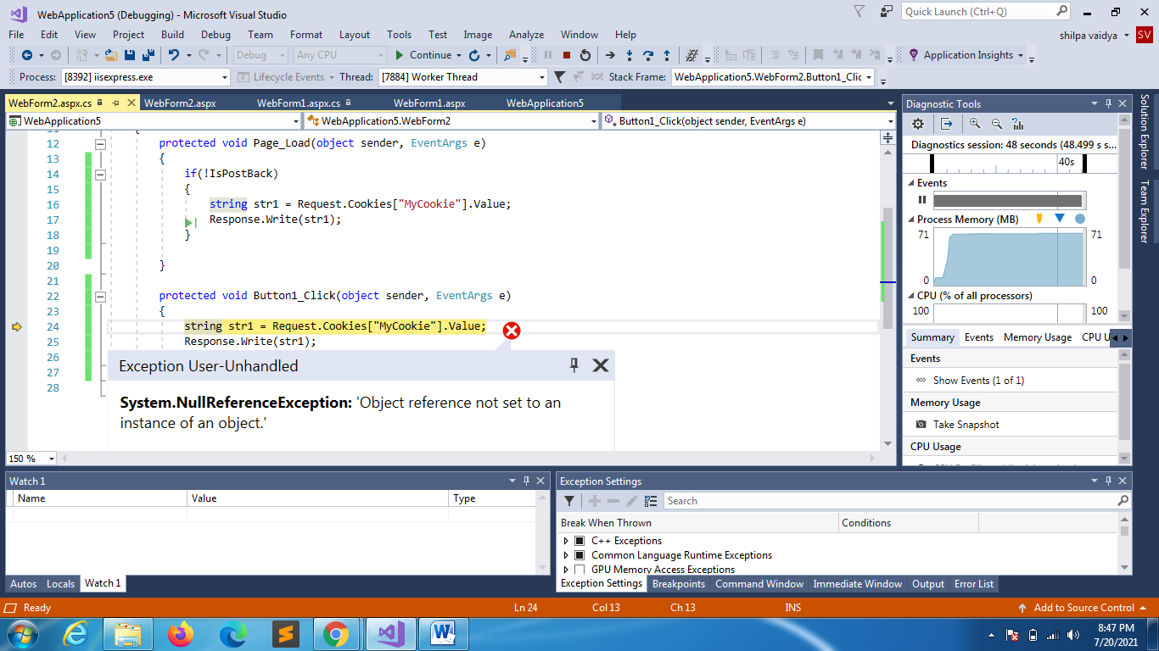

**Now storing multiple values**

**WEBFORM1**

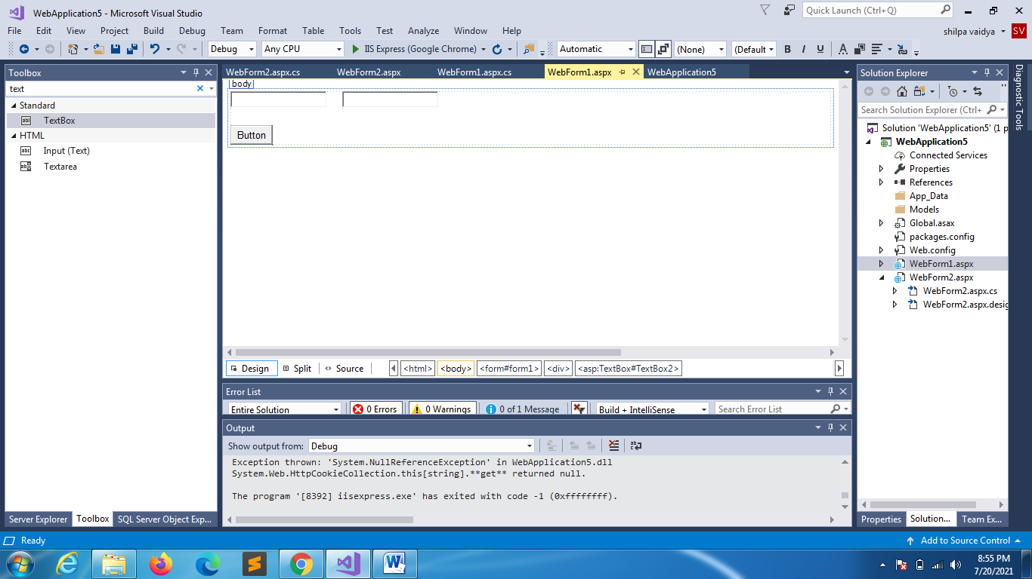

using System;

using System.Collections.Generic;

using System.Linq;

using System.Web;

using System.Web.UI;

using System.Web.UI.WebControls;

namespace WebApplication5

{

public partial class WebForm1 : System.Web.UI.Page

{

protected void Page_Load(object sender, EventArgs e)

{

}

protected void Button1_Click(object sender, EventArgs e)

{

HttpCookie cookie = new HttpCookie("MyCookie");

cookie["value1"] = TextBox1.Text;

cookie["value2"] = TextBox2.Text;

cookie.Expires = DateTime.Now.AddSeconds(30);

Response.Cookies.Add(cookie);

Response.Redirect("WebForm2.aspx");

}

}

}

**WEBFORM2**

using System;

using System.Collections.Generic;

using System.Linq;

using System.Web;

using System.Web.UI;

using System.Web.UI.WebControls;

namespace WebApplication5

{

public partial class WebForm2 : System.Web.UI.Page

{

protected void Page_Load(object sender, EventArgs e)

{

if(!IsPostBack)

{

string str1 = Request.Cookies["MyCookie"]["value1"];

string str2 = Request.Cookies["MyCookie"]["value2"];

Response.Write(str1 + " " + str2);

}

}

protected void Button1_Click(object sender, EventArgs e)

{

string str1 = Request.Cookies["MyCookie"]["value1"];

string str2 = Request.Cookies["MyCookie"]["value2"];

Response.Write(str1 + " " + str2);

}

}

}

**TO REMOVE A COOKIE**

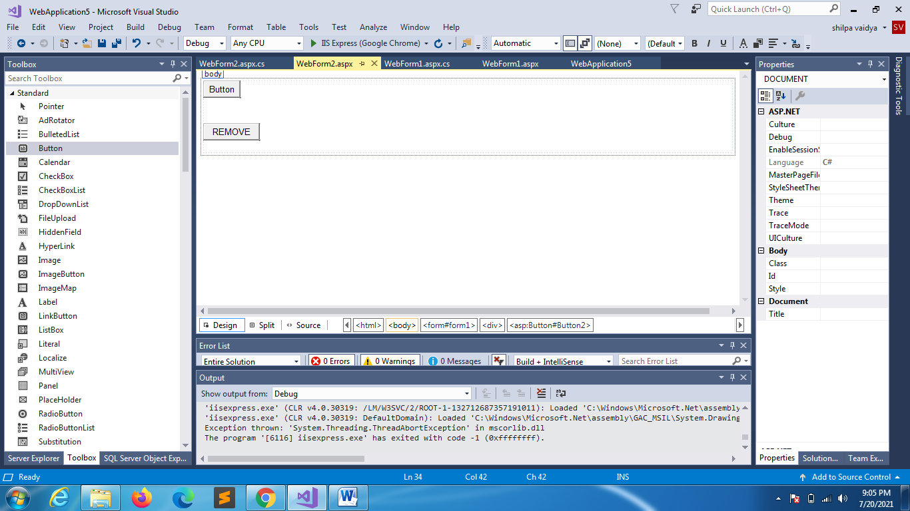

using System;

using System.Collections.Generic;

using System.Linq;

using System.Web;

using System.Web.UI;

using System.Web.UI.WebControls;

namespace WebApplication5

{

public partial class WebForm2 : System.Web.UI.Page

{

protected void Page_Load(object sender, EventArgs e)

{

if(!IsPostBack)

{

string str1 = Request.Cookies["MyCookie"]["value1"];

string str2 = Request.Cookies["MyCookie"]["value2"];

Response.Write(str1 + " " + str2);

}

}

protected void Button1_Click(object sender, EventArgs e)

{

string str1 = Request.Cookies["MyCookie"]["value1"];

string str2 = Request.Cookies["MyCookie"]["value2"];

Response.Write(str1 + " " + str2);

}

protected void Button2_Click(object sender, EventArgs e)

{

HttpCookie cookie = Request.Cookies["MyCookie"];

cookie.Expires = DateTime.Now.AddMilliseconds(-10);

Response.Cookies.Add(cookie);

}

}

}